Genetics Study Guide

- Who is the father of genetics?
- What did he study?
Match the term from column A to its definition in column B.
- Alleles
- Homozygous
- Heterozygous
- Dominant
- Recessive
- Genotype
- Phenotype
_______ Different versions of the same gene.
_______ Individuals having two copies of different alleles.
_______ An organisms genetic make-up.
_______ An organisms physical appearance.
_______ The allele that is represented with a capital letter.
_______ The allele that is represented with a lower case letter.
Simple Punnett Practice - Construct Punnett squares for the following crosses and report the predicted percentages for the offspring.
- A mother with attached earlobes (Ee) X A father with free earlobes (ee)
EE -_______% Attached earlobes –______%
Ee-________%
ee -________% Free earlobes - _____%

- A pea plant with wrinkled seeds (rr) X A pea plant homozygous for round seeds
RR-_____% Round seeds - _____%
Rr-_____% wrinkled seeds - _____%
rr - ____ %

Genetic Disorders:
Fill in the blank below with D if it is a dominant disorder and R if it is a recessive disorder.
Hemophilia _____
Red-Green Colorblindness _____

Cystic Fibrosis _____
Huntington’s _____
Sickle Cell Anemia _____
PKU _____

Explain each of the following disorders:
1. Huntington’s Disorder- ____________________________________________________
2. Cystic Fibrosis - _________________________________________________________
3. PKU- _________________________________________________________________
4. Hemophilia - ____________________________________________________________

Incomplete Dominance vs. Codominance
5. A mating between a black goose and a white goose produces blue-gray offspring. (This is an example of what inheritance? __________
6. Fill in the phenotypes below for the geese in problem #5.
B B = black
B’B’=____________
B B'=____________
7. Cross a black goose and a blue-gray goose. What percentage of offspring would be black?

Answer:__________%
8. A reddish/brown-haired cow when crossed with a white-haired cow produces offspring that have reddish/brown hairs AND white hairs (This color is called roan). This is an example of what inheritance? _________________
9. Fill in the missing genotype and phenotype below for problem #8.
RR = Reddish/Brown
___ = Roan
WW = ___________
- Cross a red cow and a white cow.
Roan: __________% %

- What are some examples of polygenic inheritance?
Karyotypes
- Why would you use a karyotype?
- There are _________ chromosomes in a human somatic cell.
- A male has _________ chromosomes for the 23rd pair and a female has _________ chromosomes for the 23rd pair.
- A person with Down syndrome has _____ total chromosomes. They have an extra chromosome in the ___________ chromosome pair.
- What is nondisjunction? What disorder(s) can it cause?

Multiple Allele Inheritance
- What makes a trait a multiple allele inheritance?
- What role do antigens play in blood type?______________ Antibodies? _____________
- Blood type ____ is considered a universal donor because _________________________
- Blood Type _______ is considered a universal recipient because ___________________
- If type A antigens come in contact with anti A antibodies, the blood will __________________, also called ___________________________.
- A woman with blood type O mates with a man who has AB. What is the possible phenotype(s) of the offspring? _______________ (show your work)
Sex-Linked Traits

- Chromosomes 1-22 are called ________________.
- A Hemophiliac male is crossed with a normal female.
What is the chance they will have a affected child? ____________

- A normal male is crossed with a female carrier for hemophilia.
What is the chance they will have a child with hemophilia? ____________

26. Can a hemophiliac father pass hemophilia on to his son? Explain why or why not.

The pedigree below is for cystic fibrosis.
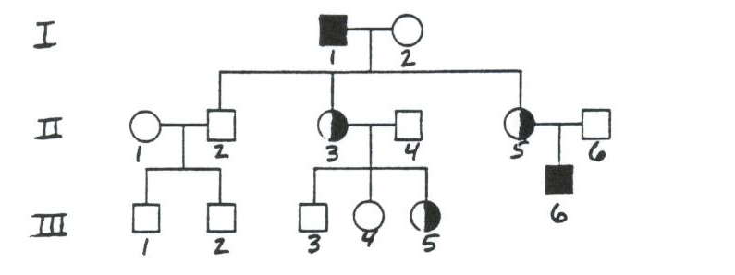
27. List the genotypes for the following individuals:
I-1:___________ II-6: __________
II-5:___________

Mitosis vs. Meiosis
 | Mitosis | Meiosis
How many cells at end? | 2
Chromosome number at end? (diploid or haploid)
Number of cell divisions? | 1
Identical or different from parent cell?
Produce what type of cells? |  | Gametes
Human chromosome number? | 46

