Ecology Study Guide
- Number the following categories in order from smallest to largest.
____Biome ____ Community ____Biosphere ____Population ____Ecosystem

- Describe what happens in a predator/prey relationship?
- What is the difference between parasitism and mutualism?
- What is the difference between biotic and abiotic?
- What are the roll of producers?
- Study the diagram below. Complete the table below by listing the organisms that occupy each trophic level.
Producers

Primary Consumer
Secondary Consumer
Tertiary Consumer
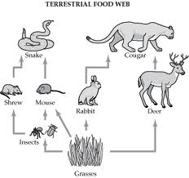
- In the diagram above, what is the relationship between the rabbit and cougar?
- In the diagram above, what type of heterotroph is the Deer? Mouse? Cougar?
- In a food web, the arrows show the flow of?
- Why are decomposers important to the ecosystem?
- Name 4 reasons why only 10% of energy is transferred from one trophic level to the next.
- Explain how decomposition contributes to the carbon cycle.
- What is the role of plants in the carbon cycle?
- How does burning of fossil fuels impact the carbon cycle?
- What role do humans play in the carbon cycle?
- What is the role of bacteria in the nitrogen cycle?
- Draw and label a graph that illustrating exponential growth meeting its carrying capacity.
- What are 3 factors that affect population size?
- How do limiting factors affect population growth?
- List 3 resources that might become scarce as the human population continues to grow.
- List & explain some ways that humans can have a negative impact on an ecosystem.
- What are the effects of deforestation to the ecosystem?
- Name 2 factors that increase global warming and 2 factors that decrease global warming.
- How is the greenhouse effect connected to global climate change?
- What are the hazards of using pesticides?
- Eutrophication is caused by which chemicals?
- What is an invasive species and how is it harmful to the ecosystem?
- In bio-magnification (bio-accumulation), which trophic level has the highest concentration of pesticide?
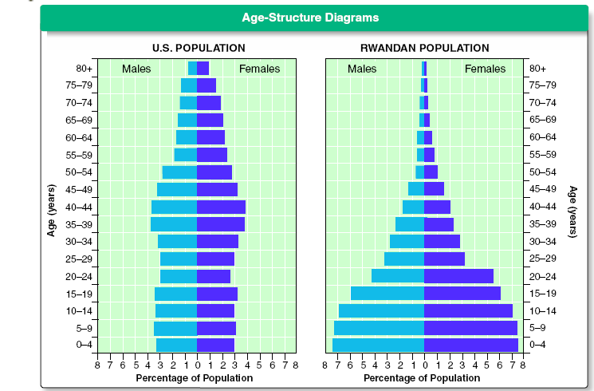
- According to the above diagram which population is growing rapidly?
- Give two examples on how to reduce your ecological footprint.
- What are some benefits and negative effects of Hog farms?
- Draw a simple diagram on how CO₂ cycles through the ecosystem.
- Why were Jetties built on the coast?
- Pfisteria infects which organisms?
- Dutch Elm disease effects which organisms?

