Biotechnology
- What is the purpose of restriction enzymes?
- What process is used to separate DNA?
- What process is occurring below?

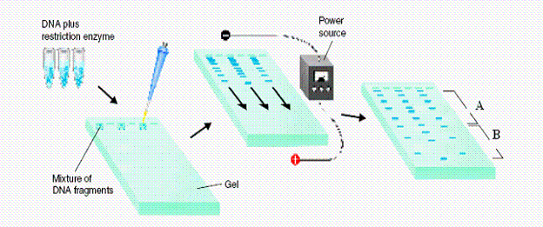

- Which strands move further through the gel (A or B)?
- What is the purpose of DNA fingerprinting?
- Put the steps of gel electrophoresis in order.
_____“Load” fragments into a gel, run an electric current. DNA is (-) and will move to the (+) end.
_____ Collect DNA sample (blood, hair, etc.)
_____ Smaller fragments move faster creating a band pattern on the gel – then you read the pattern
_____ Cut DNA with restriction enzymes
- Which strand of DNA matches the DNA evidence below?
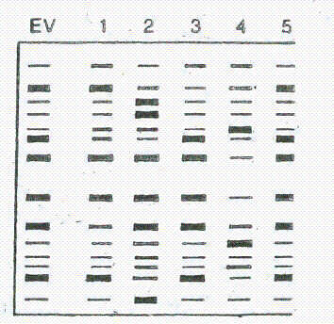

- In the production of a transgenic bacteria to make the human growth hormone (HGH), put the following sequences in order.
____ Recombinant DNA is transferred into a suitable bacterial host, creating a transgenic organism
____ The plasmid and DNA fragment are cut with restriction enzymes
____ The DNA fragment to be inserted into the plasmid is isolated.
____ A plasmid is removed from a bacterial cell and a gene for HGH is removed from DNA

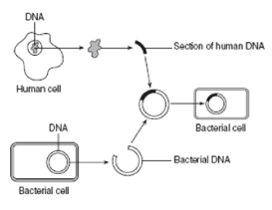
- Labe the above diagram
- What are some positives and negatives of transgenic organisms?
- What was the purpose of the human genome project?
- When a bad gene is corrected with a good gene, this is called?

- Explain the steps of cloning.

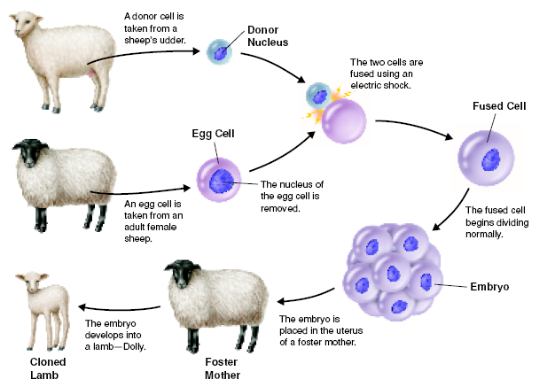

DNA/Protein Synthesis
- How are human traits determined?
- Why are there so many different physical appearances among humans?
- What are the 3 main differences between RNA and DNA?
- List the function of the following RNA
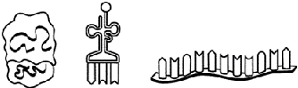
rRNA tRNA mRNA

- What is the function of DNA?
- What weak bond holds the nitrogen bases together?
- What is a codon and what does represent?
- What bond holds amino acids together?
- What is a mutation?
- What causes a mutation?
- Which mutations can be passed to the offspring?
- What type of mutation are the following?
  - ATA CTA GGC AAC TAG GC

  - ATA CTA GGC ATA CAA GGC

- In what phase of the cell cycle does replication occur and where?
- Replicate the following strand of DNA: TAC TTA GCC ACC GTA

- Transcribe & Translate the following strand of DNA: TAC TTA GCC ACC GTA

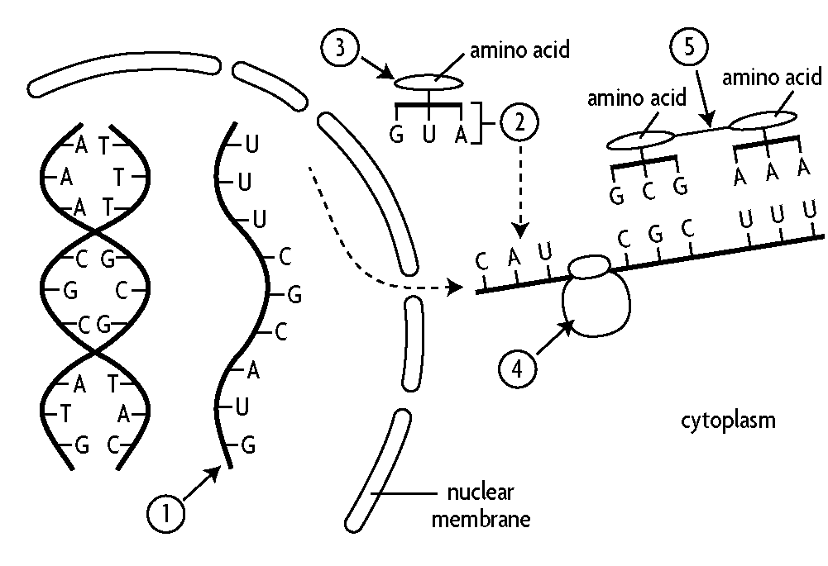

- Label the above diagram
- What process is occurring at X?
- What process is occurring at Y?
- What is the shape of DNA? Who discover the shape?
- What enzyme untwist DNA during replication and transcription?
- If you have 20% Thymine; how much:
  - _____________ Adenine
  - _____________ Guanine
  - _____________ Cytosine

- DNA mRNA Protein

DNA

